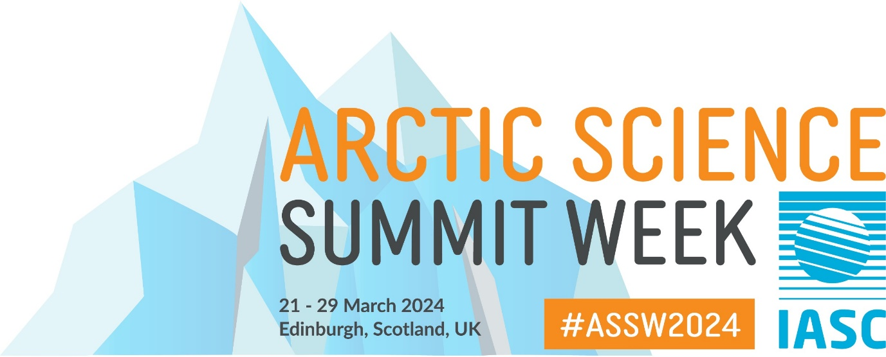

Session title: How well do we understand change throughout the Arctic and what impact is the war in Ukraine having on this?

Timing: Monday 25 March at 16-17:30 (UK time)

Agenda:
- Welcome and introduction, Elmer Topp-Jørgensen
- The rise and fall of INTERACT Science Diplomacy, Terry Callaghan and Margareta Johansson (INTERACT)
- How is the war in Ukraine impacting our ability to observe and predict Arctic Change, Elmer Topp-Jørgensen (INTERACT)
- UArctic thematic networks’ cooperation in a time of crisis, Kirsi Latola (UArctic Vice President Networks)
- Arctic Council pause: The AMAP perspective – response, development, and recently updated guidance (Rolf Rødven, AMAP Executive Secretary)
- Open discussion on institutional and personal experiences and potential for resuming collaborations, Margareta Johansson and Elmer Topp-Jørgensen (INTERACT)

