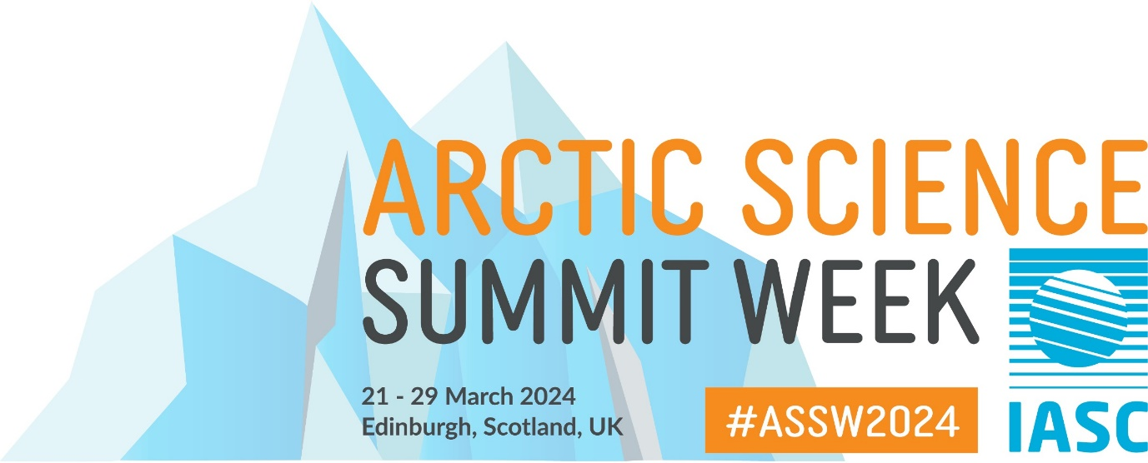
Running order for AWG ASSW Open Meeting, Friday 22 March 08:30 - 15:30 UTC

- 08:30-08:40 - Welcome (Session Chair Gijs de Boer, on-site, no slides)
- 08:40-08:50 - Introductions of AWG members (Sonja Murto, on-site, no slides)
- 08:50-09:05 - Icebreaker with participants in the room and online, moderated by Gijs de Boer (no slides)
- 09:05-09:20 - Report from the AWG Chair (Gijs de Boer, on-site, no slides)
- 09:20-09:30 - Review and approval of last meeting minutes with participants in the room and online, moderated by Gijs de Boer (Word document shared on-site)
- 09:30-09:40 - Review and adoption of the agenda with participants in the room and online, moderated by Gijs de Boer (possibly Word document shared on-site)
- 09:40-09:50 - 2024 Fellow perspectives (Patrik Winiger, on-site, PowerPoint presentation)
- 09:50-10:00 - 2023 Fellow perspectives (Rémy Lapere, on-site, PowerPoint presentation)
10:00-10:30 - COFFEE BREAK
- 10:30-10:35 - Introduction to session (Gijs de Boer, on-site, no slides)
- 10:35-10:40 - 3rd MOSAiC Science conference (Annette Rinke, on-site, PowerPoint presentation)
- 10:40-10:45 - MOSAiC: improved BL modeling in climate models (Laurens Ganzeveld, on-site, PowerPoint presentation)
- 10:45-10:50 - HELiPOD at MOSAiC - status of data and first results (Falk Pätzold, online, PowerPoint presentation)
- 10:50-11:00 - ARTofMELT spring 2023 expedition (Michael Tjernström & Sonja Murto, on-site, PowerPoint presentation)
- 11:00-11:10 - Air Pollution in the Arctic workshop update (Stephen Arnold, on-site, PowerPoint presentation)
- 11:10-11:20 - Arctic Geoengineering - 1st workshop (Julia Schmale, online, PowerPoint presentation)
- 11:20-11:30 - Polar Vortex Workshop Update (Muyin Wang, on-site, PowerPoint presentation)
- 11:30-11:40 - Introducing the new WMO Polar Prediction Project (PCAPS) (Jørn Kristiansen, online, PowerPoint presentation)
- 11:40-11:50 - CERTAINTY introduction and overview (Jennie Thomas, on-site, PowerPoint presentation)
- 11:50-12:00 - CleanCloud introduction and overview (Stefano Decessari, on-site, PowerPoint presentation)
- 12:00-12:10 - GreenFjord: Greenland fjord ecosystems & changing climate (Julia Schmale, online, PowerPoint presentation)
- 12:10-12:20 - Dutch Arctic Scientific Activities Update (Laurens Ganzeveld, on-site, PowerPoint presentation)
- 12:20-12:30 - Open discussion with participants in the room and online, moderated by Gijs de Boer (no slides)
12:30-13:30 - LUNCH BREAK
- 13:30-13:40 - Introduction to ICARP-IV (Sourav Chatterjee, online, PowerPoint presentation)
- 13:40-14:00 - Discussion on AWG engagement with ICAPR-IV with participants in the room and online, moderated by Gijs de Boer (no slides)
- 14:00-14:30 - Discussion to define the IASC AWG Value Proposition with participants in the room and online, moderated by Gijs de Boer (no slides)
- 14:30-15:15 - Development of the Implementation Plan with participants in the room and online, moderated by Gijs de Boer (Word document shared on-site)
- 15:15-15:30 - Closing thoughts & next steps (Gijs de Boer, on-site, no slides)

